# Lab Manual 6

# Decoders

## Objectives

To learn and understand the working of Decoders

## 2-to-4 line decoders

74LS139 IC contains two fully independent 2-to-4 line decoders with active low enables. The function table and connection diagram for this IC are shown below:

Function Table

|  |  |  |  |  |  |  |
| --- | --- | --- | --- | --- | --- | --- |
| **Enable** | **Selection Inputs** | | **Outputs** | | | |
| **G** | **B** | **A** | **Y0** | **Y1** | **Y2** | **Y3** |
| H | X | X | H | H | H | H |
| L | L | L | L | H | H | H |
| L | L | H | H | L | H | H |
| L | H | L | H | H | L | H |
| L | H | H | H | H | H | L |

H= Logic High, L= Logic Low, X= Don’t Care

Connection Diagram

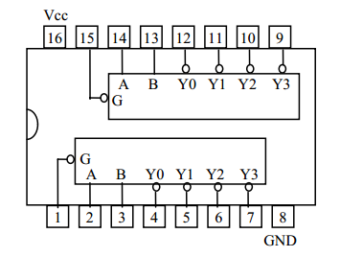

## 3-to-8 line decoders

74LS138 IC contains 3-to-8 line decoder. The function table and connection diagram for this IC are shown below:

Function Table

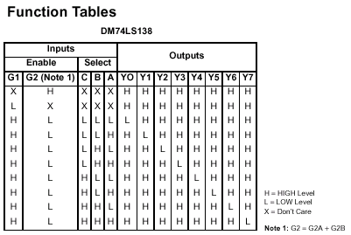

Connection Diagram

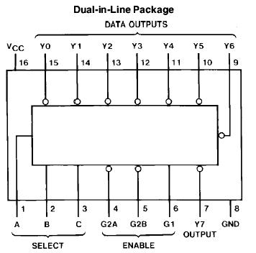

## Problems / Assignments

|  |  |
| --- | --- |
| Problem 1 |  |

Implement 4 to 16-line decoder by using the following rules on Logic works only.

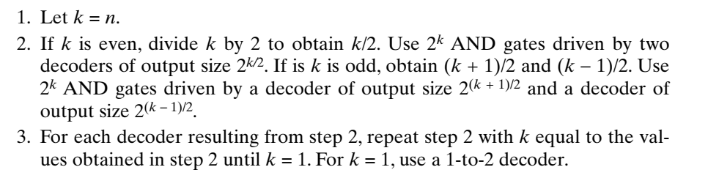

|  |  |
| --- | --- |
| Problem 2 |  |

An electronic game uses an array of seven LEDs (light-emitting diodes) to display the results of a random roll of a die. A decoder is to be designed to illuminate the appropriate diodes for the display of each of the six die values. The desired display patterns are shown in Figure.

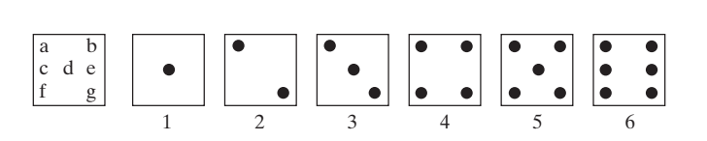

1. Use a 3–to–8-line decoder and OR gates to map the 3-bit combinations on inputs X2, X1, and X0 for values 1 through 6 to the outputs a through g. Input combinations 000 and 111 are don’t-cares. For output, use LEDs arranged as shown in the figure.
2. Note that for the six die sides, only certain combinations of dots occur. For example, dot pattern A = {d}and dot pattern B = {a, g} can be used for representing input values 1, 2, and 3 as {A}, {B}, and {A, B}. define four dot patterns A, B, C, and D, sets of which can provide all six output patterns. Design a minimized custom decoder that has inputs X2, X1, and X0 and outputs A, B, C, and D. For output, use LEDs arranged as shown in the figure.

**Note: You don’t need to submit truth table or K-maps. Just submit the finalized circuit implementation on Logicworks.**